**CSE3506 – ESSENTIALS OF DATA ANALYTICS**

**EXPT NO: 8**

**DATE:** 31st March 2021

**NAME:** R. Harini

**REG. NO.:** 18BCE1010

**HIERARCHICAL CLUSTERING**

**AIM**

Understanding hierarchical clustering on USArrests Dataset and performing the same for Iris dataset with different linkage methods.

**R LAB PROGRAM**

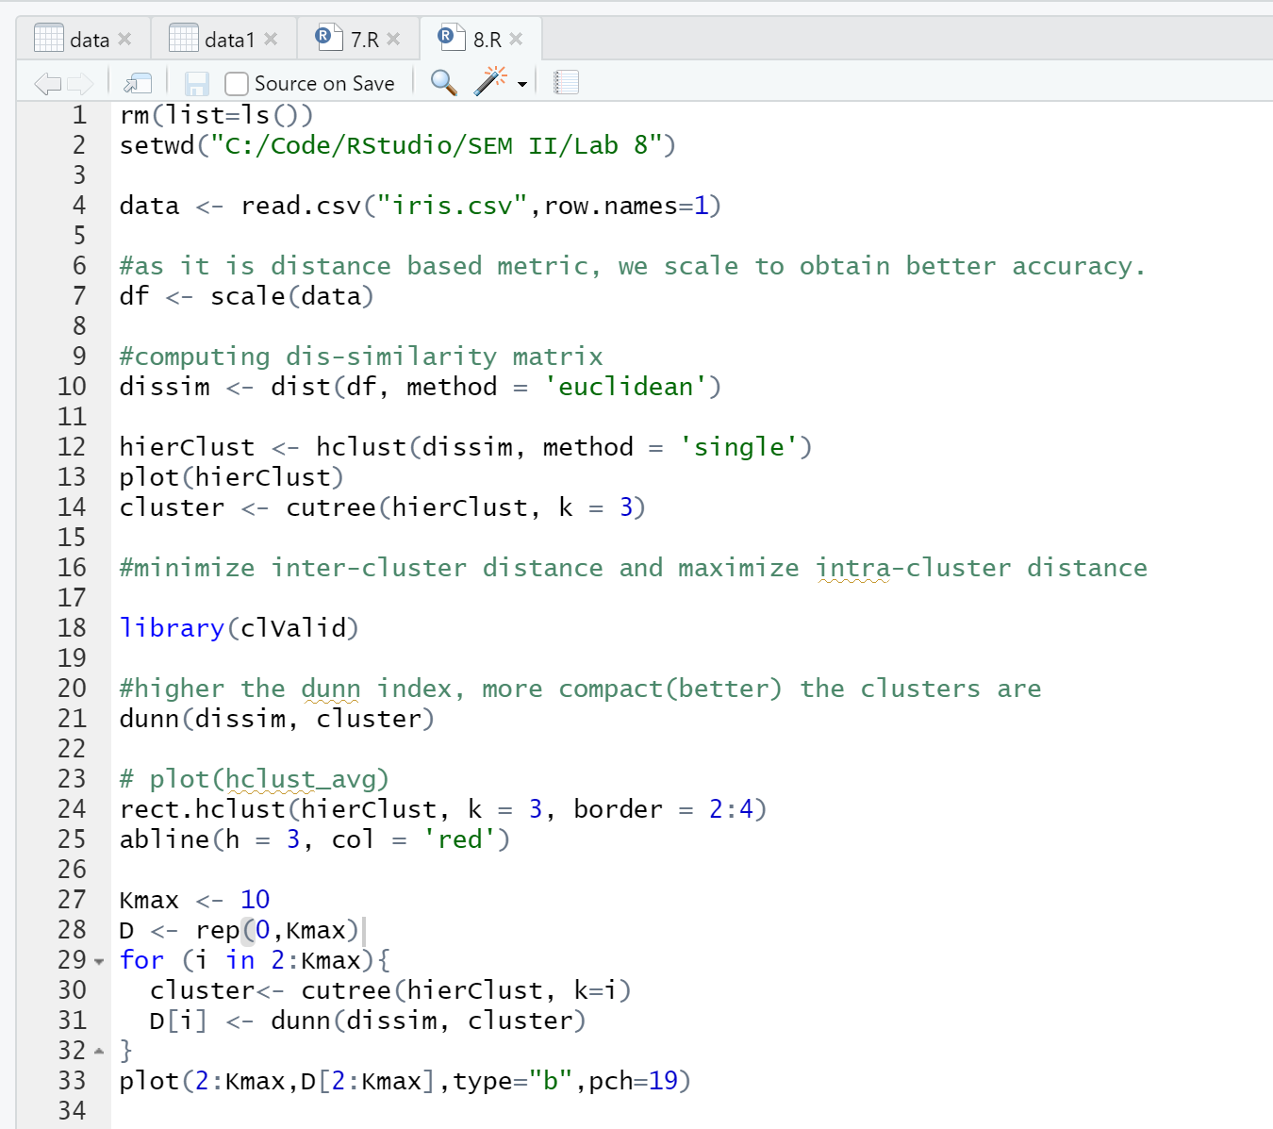

**OUTPUT**

1. **Single Linkage**

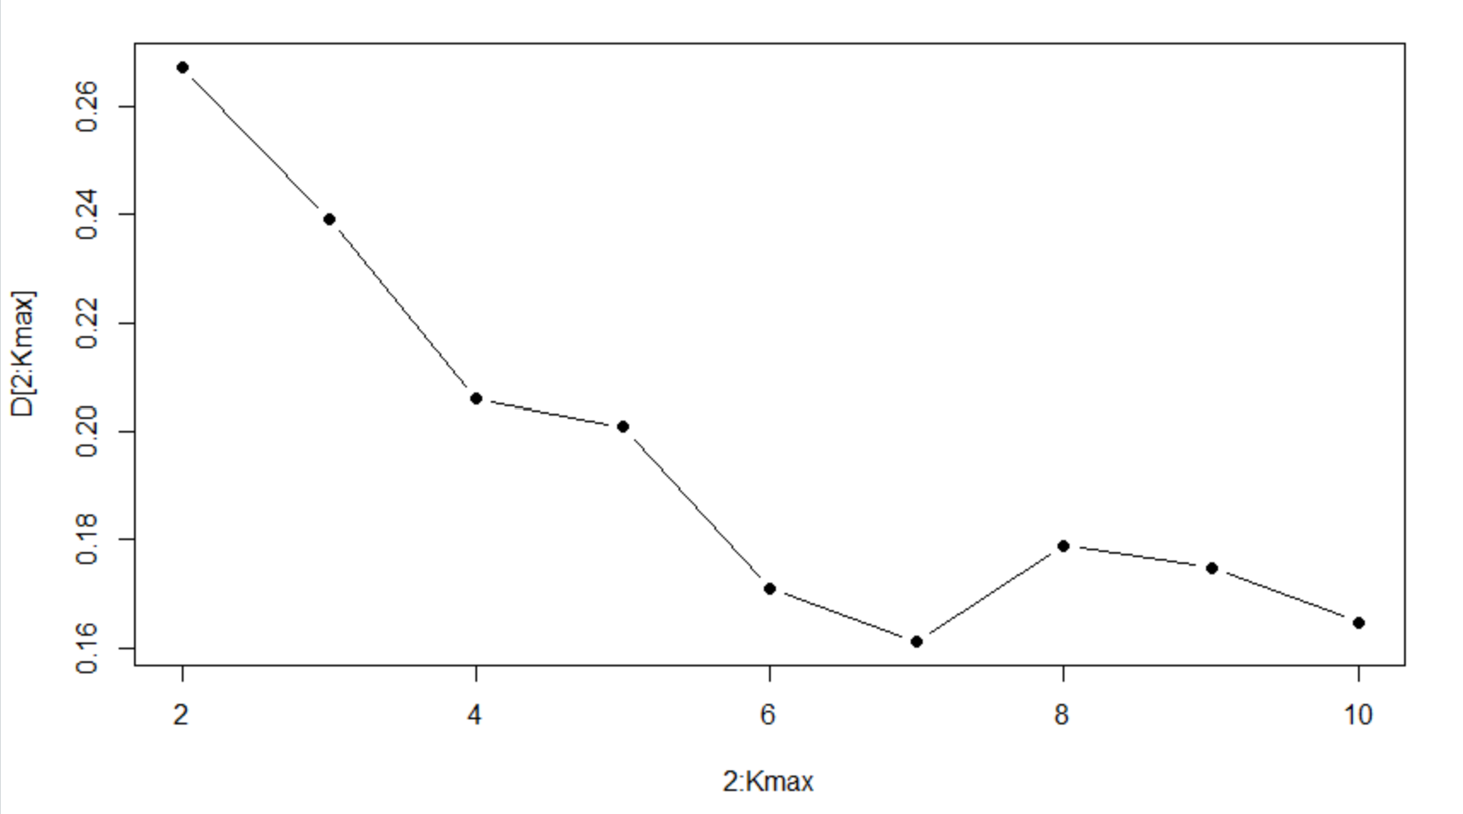

1. **Average Linkage**

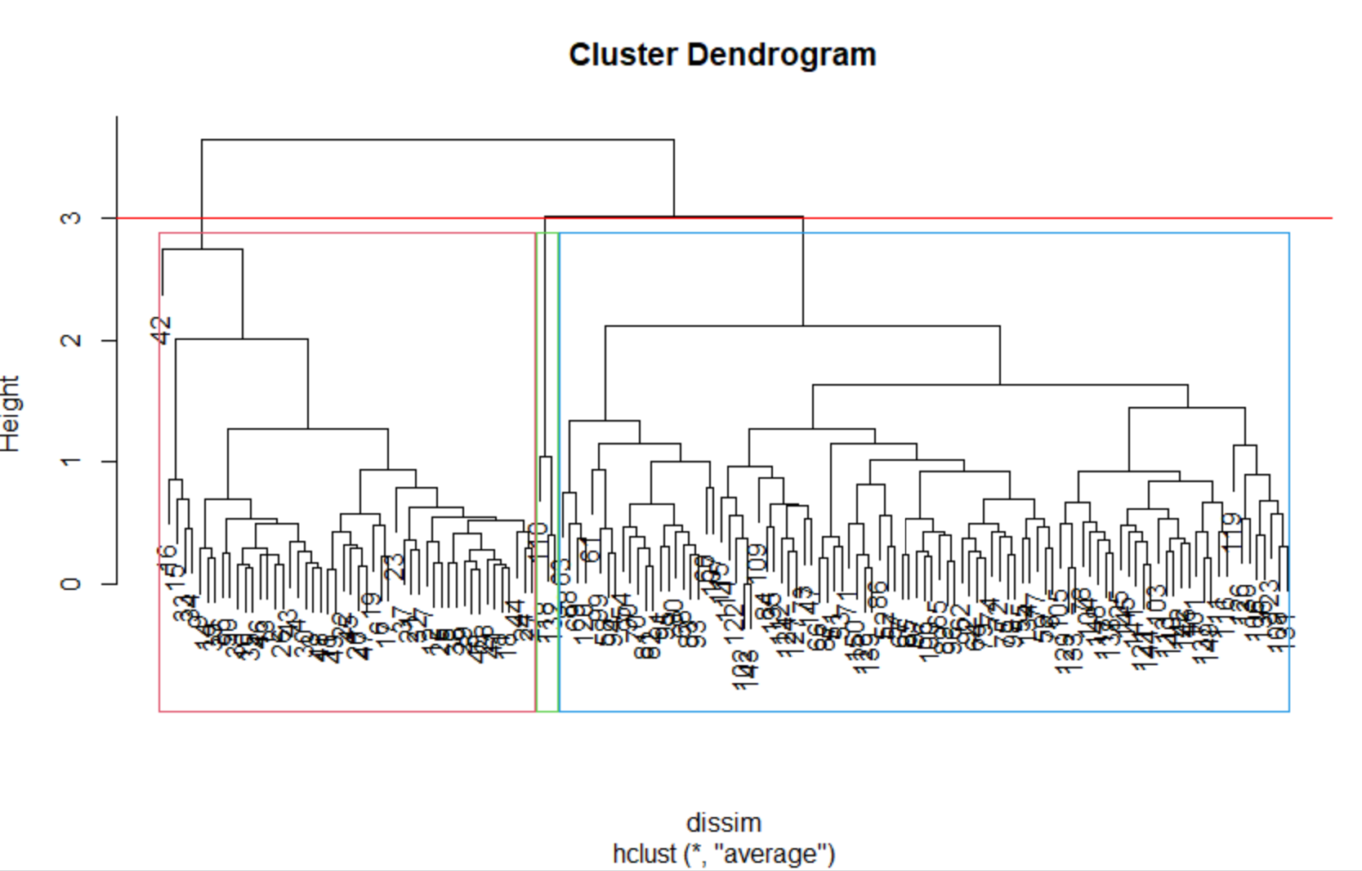

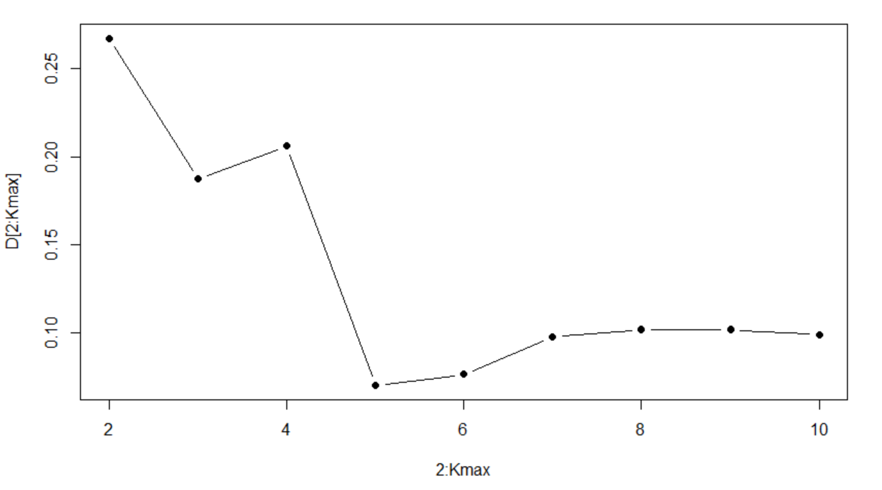

1. **Complete Linkage**

